Assignment date: 16th may 2026
Machine learning
Python
ABHAY RAJ

1Q. Check if a no. is palindrome:
a. 121
b. 343
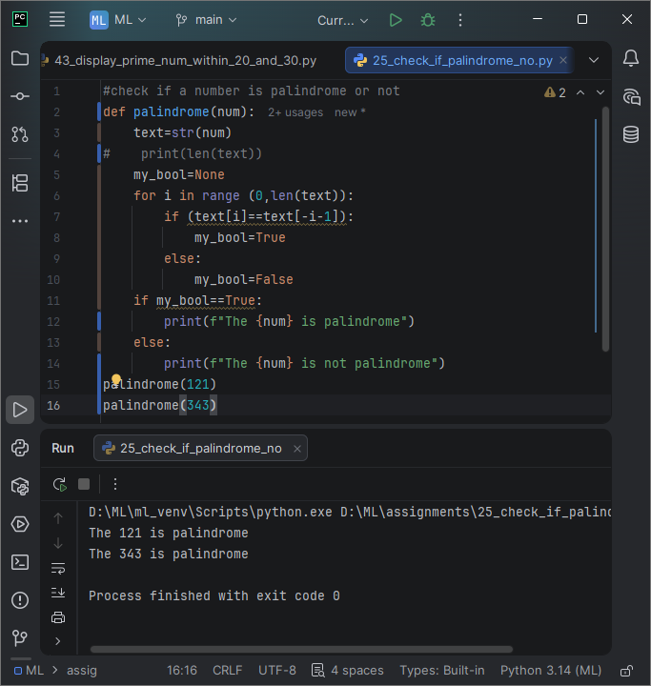
Q2. Check factorial of a number
- 5
- 10
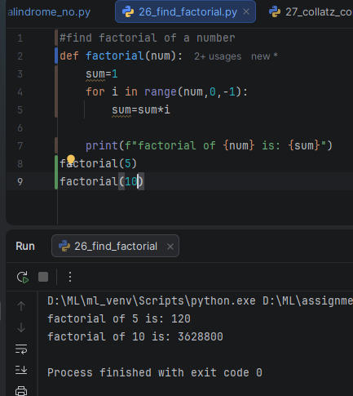
Q3. Collatz Conjecture: Generate a sequence until it reaches 1.
a. n=6
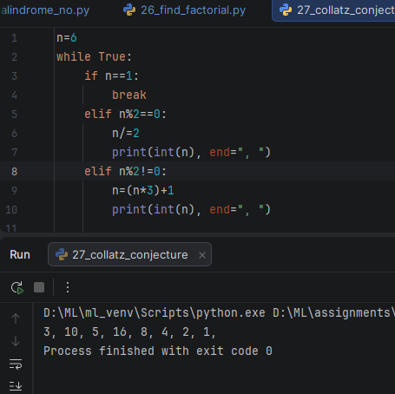
Q4. Armstrong no. check.
Num= 153
input
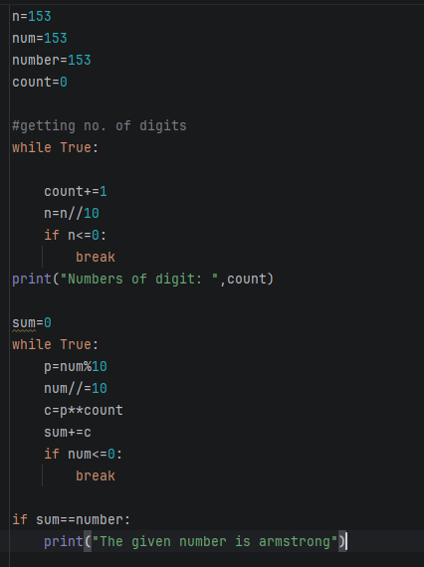
output
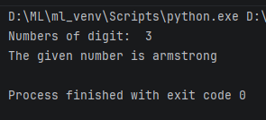

Q5. Print right-angled triangle no. pattern using a loop.
Given height=5
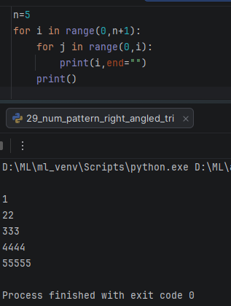
Q6. Using above question print decreasing pattern.
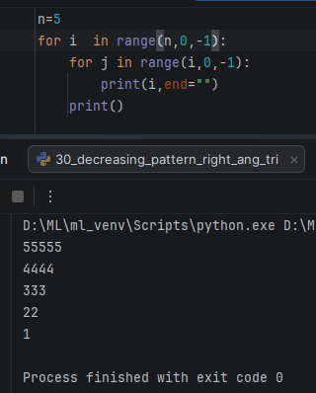

Q7. Print alternate no. pattern
(Range 1 to 20)
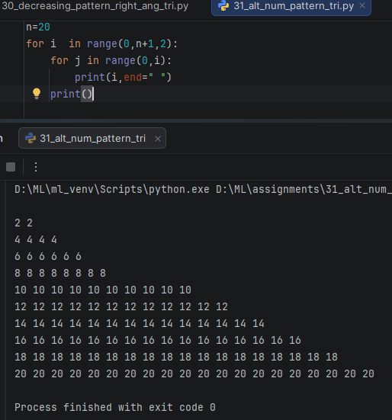
Q8. Print Alphabet pyramid (A,BB,CCC)
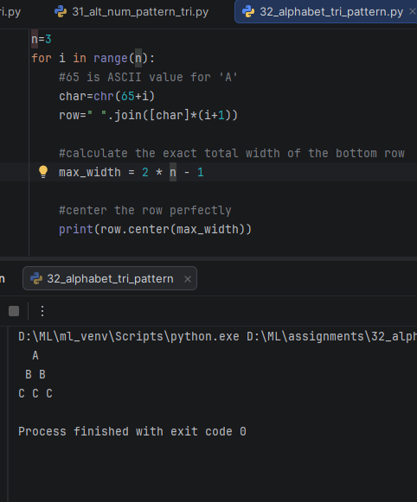
Q9. print hollow square pattern
Size=5
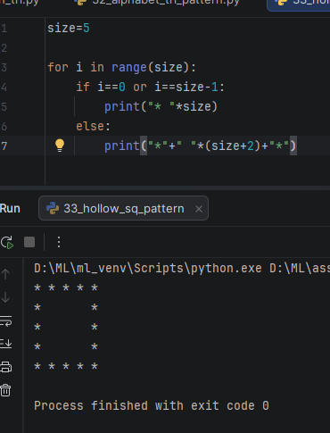
Q10. print pyramid pattern of stars
Rows=5
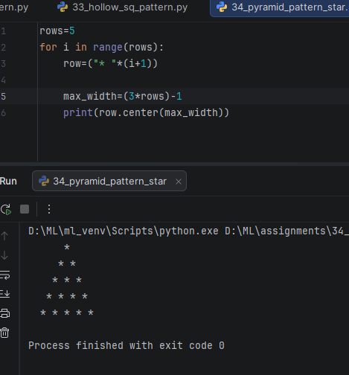
Q11. Print full multiplication table (1 to 100)
input
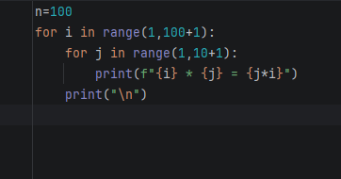
output
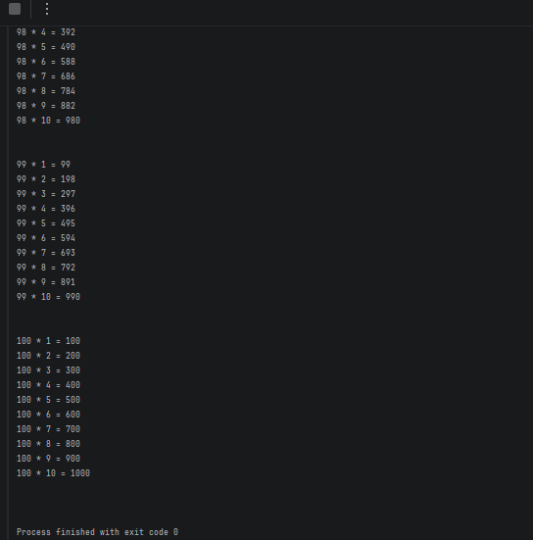

Q12. Dictionary Filter:
Extract pairs where value exceeds a threshold.
Given input:
Scores={“Abhay”: 85, “Sachin”:70}
threshold=75
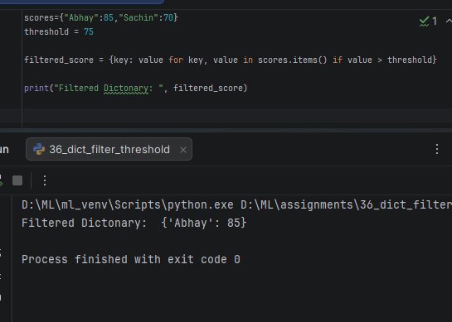
Q13. Remove duplicates without set
Input: [1,2,2,3,4,4,4,5]
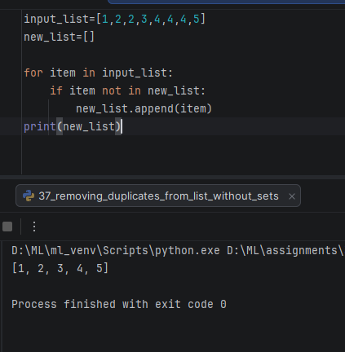
Q14. word frequency counter
Input: text=”apple banana apple orange banana apple”
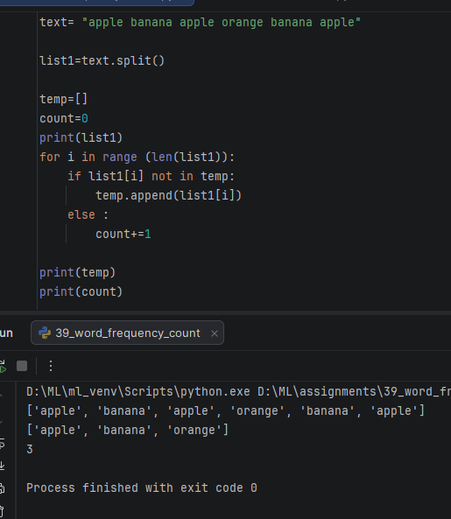
Q15. Display Fibonacci series upto 10 terms.
Input: n_terms=10
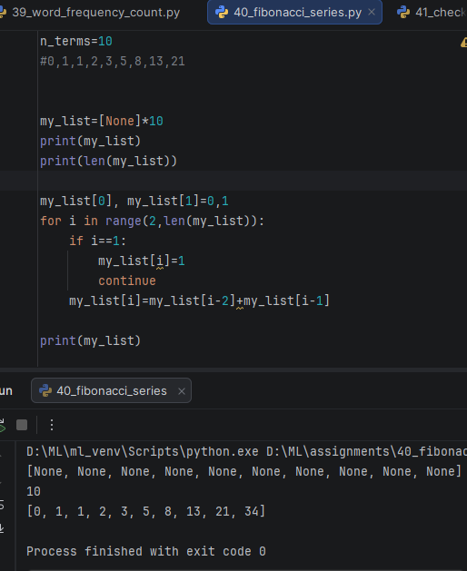
Q16. check whether 28 is a perfect number or not.
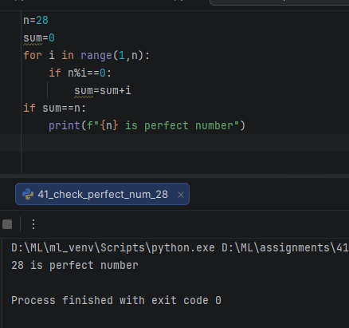
Q17. binary to decimal conversion using loop.
Input : binary_str=”1101”
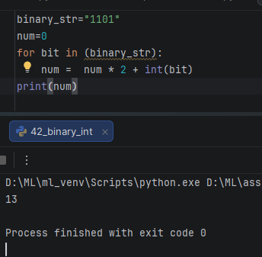
Q18. display all prime no. within 20 and 30
